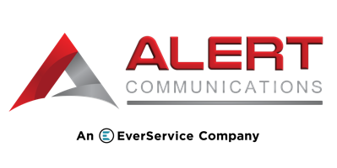

Industry: Personal Injury

Client Name: Cofman Townsley

**CASE STUDY:**

**Injury Firm Grows Revenue with Intake**

**and Retainer Services**

Overflow, nights, weekends and holiday coverage

Added live chat and SMS on website

Introduced retainer services

Ensured calls were answered within 10 seconds

Provided overflow answering services

Utilized Alert Intake Specialists for qualified intakes

Of Maximizing Revenue

**10 second**

**800-211-4563**

**www.alertcommunications.com**

**Results**

**4 Years**

Answer Rate

Qualified Intakes Per Month

**50**

Increase in Conversions

Availability With More Calls Answered

**24/7, 365**

**25%**

**Solutions**

Missed calls after hours

Inconsistent lead capture

Low contract signing rates

Slow response times

Overloaded office staff

Limited scalability for client intake

**Problems**

Since 2020, Alert has supported Cofman Townsley, a St. Louis personal injury firm known as trusted advocates for injury victims. They sought Alert’s partnership to first provide 24/7/365 legal intake and retainer services.

**Overview**